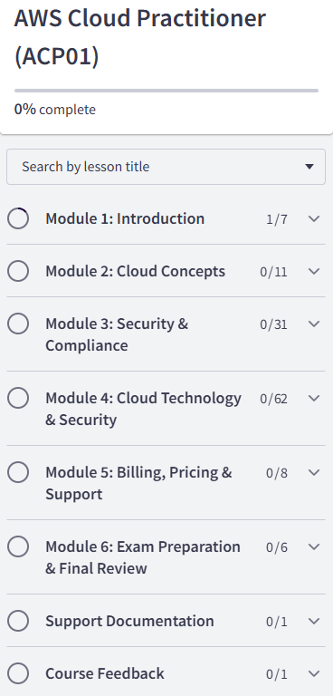
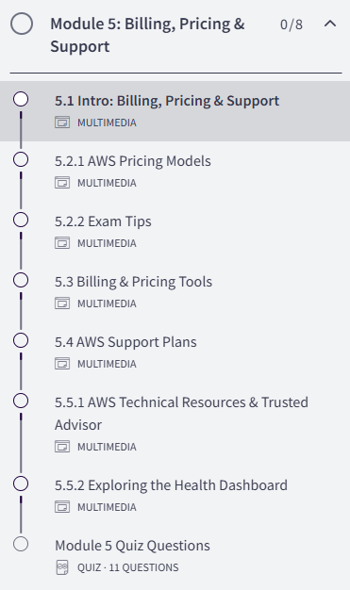



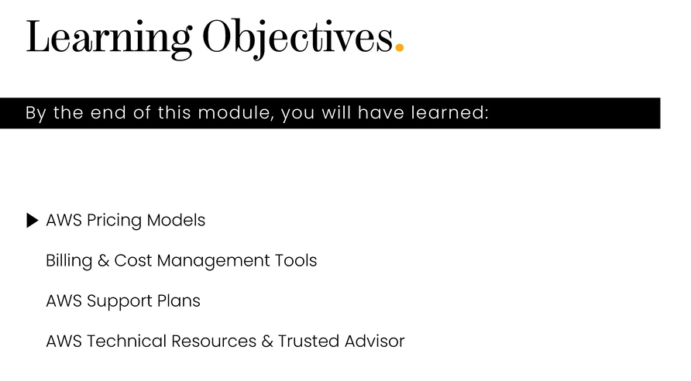



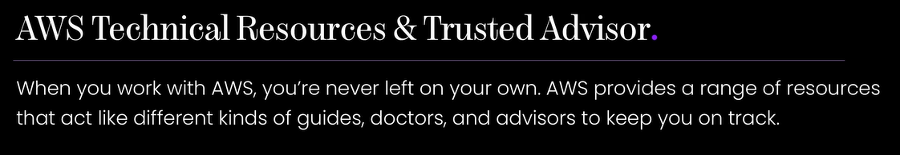
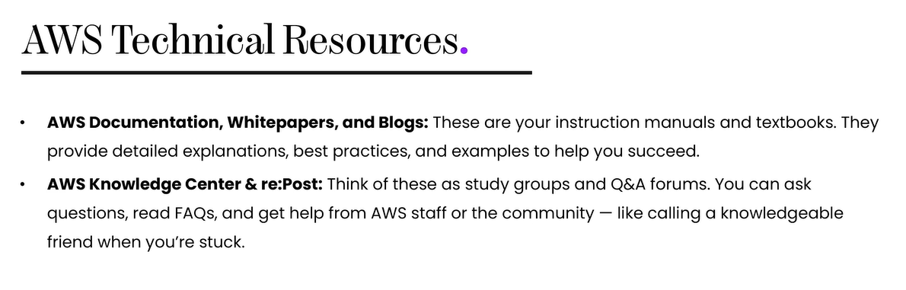
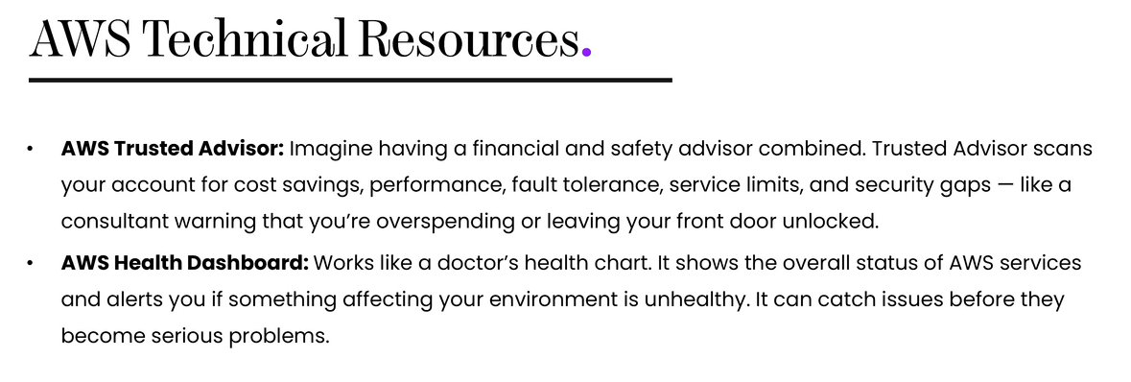
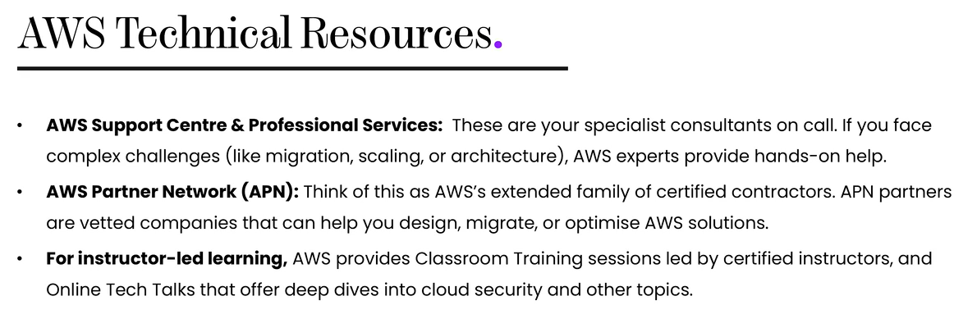

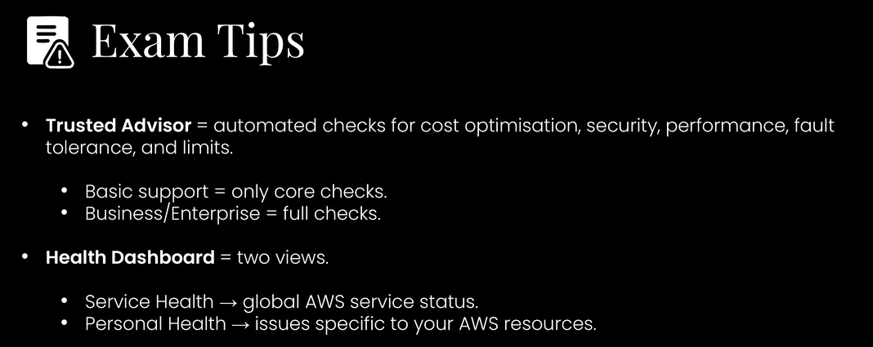

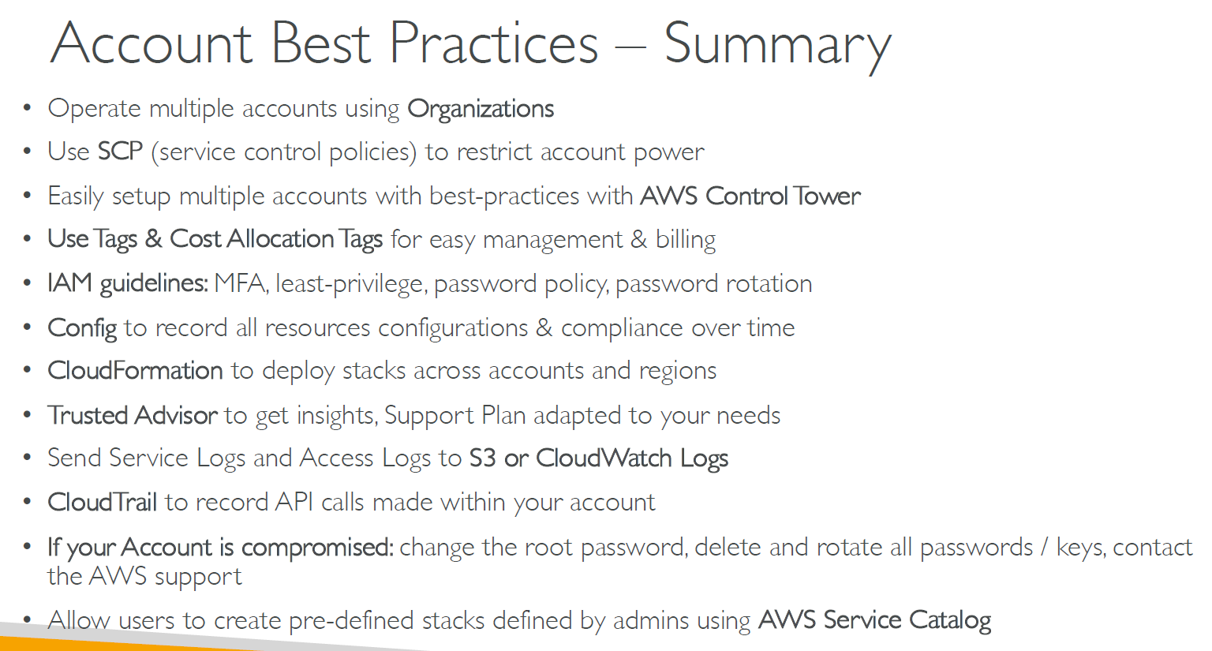
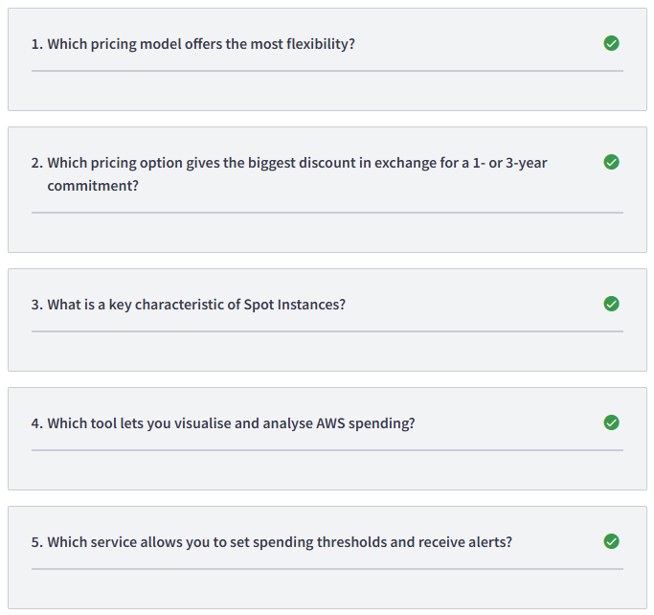

1/ On-Demand Instances
2/ Reserved Instances
3/ Low cost but can be interrupted
4/ AWS Cost Explorer
5/ AWS Budgets
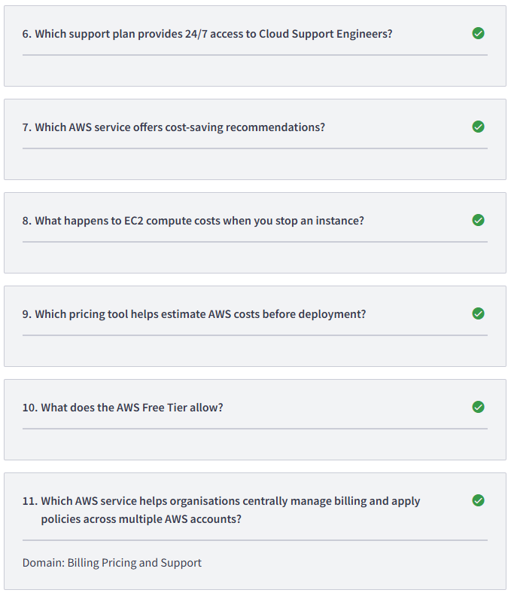
6/ Business Tier
7/ Trusted Advisor
8/ Compute charges stop but storage costs continue
9/ AWS Pricing Calculator
10/ Free usage within specific limits for 12 months or always free
11/ AWS Organizations

